**SI units conversion tutorial**

**SI units:** (System International Unit) Internationally recognized units of measurement of physical quantities.

Example of SI units are **meter** to measure **length**, **second** to measure **time**, and **kilogram** to measure **mass** (or weight).

Table indicates the SI units, quantities, and symbol

|  |  |  |
| --- | --- | --- |
| **Quantity to be measured** | **SI Unit** | **Symbol** |
| Length | Meter | m |
| Mass | Kilogram | kg |
| Temperature | Kelvin | K |
| Time | Second | s, sec |
| Electric current | Ampere | A |
| Light intensity | Candela  (*or candle*) | cd |

Generally, it is **not** possible to convert an SI unit to another if the quantity to be measured is different *(we can’t convert kilogram to second*)

Oftentimes, scientists take measurements and find the measurement to be too small,   
example 0.005 meter and sometimes there are too many zeroes, so, SI prefixes are commonly used instead of writing many 0s

**ex1)** the width of your hair is 0.00002 meter,   
in this example we measure the width of a hair and find that it measures 0.00002 meter, but it would be simpler to use prefix to reduce the number of zeroes as in 20 micrometers

**ex2)** The distance between Baghdad and Kirkuk is 350000 meters, it would be easier to write it with less zeroes by using an SI prefix  
as in 350 kilometers

*\*Note: these two examples are just to show why we need prefixes*

SI units often have ***prefixes*** attached before them to indicate what is the magnitude of the SI unit. *(Kilometer instead of 1000 meter,   
or millisecond instead of 0.001 second)*

An SI **prefix** **is a** **multiplier** that precedes a written SI unit to indicate its magnitude

|  |  |  |
| --- | --- | --- |
| **Prefix name** | **Multiplier X** | **Scientific notation** |
| kilo- | 1000 | 1x10³ |
| **(Base SI Unit)** | 1 | 1 |
| centi- | 0.01 | 1x10⁻² |
| milli- | 0.001 | 1x10⁻³ |
| micro- **μ** | 0.000001 | 1x10⁻⁶ |
| nano- | 0.000 000 001 | 1x10⁻⁹ |

In the table, any prefix below (**SI unit)** is smaller, any quantity above (**SI unit)** is larger.  
  
It is possible to convert a prefix of an SI unit to another prefix as the quantity to be measured remains the same, the only thing changing is the number of zeroes and the decimal point.

\****Rule*** *to help check your work*: As the prefix gets larger, the *number* gets smaller and as the prefix gets smaller, the number gets bigger  
  
 **ex)** (40 microA = 0.00004 A)

# looks large # looks smaller

The unit prefix(km) is bigger, so the result number should look smaller

**4m 🡪 km**   
 4m ÷ 1000 = 0.004 km

The result number 0.004 is smaller than the number 4, so the result is certainly correct

**55A 🡪 kA**  
 55A ÷ 1000 = 0.055 kA

**78 gram 🡪 kilogram**   
 78 ÷ 1000 = 0.078 kilogram  
 *(alternatively, we can multiply by 0.001)*

**859 cd 🡪 kcd**   
 859cd ÷ 1000 = 0.859 kcd

* In order to convert from **Base unit** to any prefix, we just divide with the prefix multiplier
* In order to convert from prefix to the **Base unit**, we just multiply with the multiplier

The prefix unit gets smaller, so the number should look bigger

**478A 🡪 mA**   
478 ÷ 0.001= 478000 mA

**3m 🡪 μm**   
 3m ÷ 0.000001 = 3000000 μm

**974 kg 🡪 g**  
 974kg x 1000 = 974000 g

**△** Remember Kilogram already has kilo in it, so it’s considered already prefixed, **gram is the base unit, but kilogram is the SI unit.**

To convert from a prefix to another, the easiest method is to make it a 2-step process,   
 step 1. Convert the first unit to the   
 **Base SI unit** without prefix

Step 2. Convert from **Base SI unit** to the  
 required unit

Example:   
 **48 μg 🡪 kg**

First step, 48 μg 🡪 grams

**48 x 0.000 001 = 0.000 048 gram**

Second step, gram 🡪 kilogram  
0.000 048 gram x 0.001 = 0.000 000 048 kg

***How the teacher thinks:***

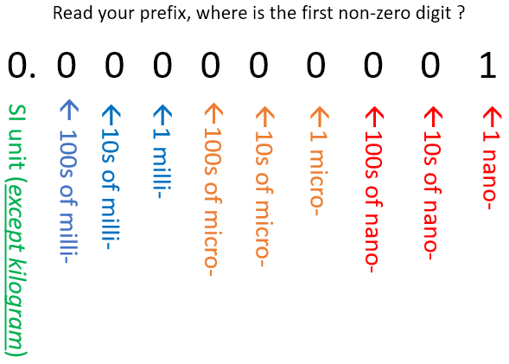

Example with decimal point

**38.5 mmol 🡪 μmol**

Method 1

38.5 ÷ 0.001 = 38500 μmol

When going farther from the base SI unit,   
we divide by the difference of numbers   
(milli is 0.001, micro is 0.000 001),

***OR*** method 2

**38.5 mmol 🡪 μmol**First, we think of it as

The unit gets bigger, so the number should look smaller

**38.5 mmol 🡪 mol  
38.5 x 0.001 = 0.0385 mol**

Second, mol 🡪 μmol  
0.0385 mol 🡪 μmol  
0.0385 ÷ 0.000001 = 38500 μmol

**Example**  
411 kg 🡪 μg

Step 1. 41 kg 🡪 g  
 41 X 1000 = 41000 g

Step 2. 41000 g 🡪 μg  
 41000 ÷ 0.000 001 = 41 000 000 000 μg

For time conversion:

1 day = 24 hour   
1 hour = 60 minutes  
1 minute = 60 seconds

To convert from hour to minute we multiply by 60, and from hour to second we multiply by 3600

The opposite is dividing when converting second to minute, and minute to hour, and so on…

**Ex)** 4.5 hour 🡪 sec  
 4.5 X 3600 = 16200 sec

**Ex)** 4320 second 🡪 hour  
 4320 ÷ 3600 = 1.2 hour

**Ex)** 2 days 🡪 minutes  
 2 days 🡪 hours 🡪 minutes  
 2 days X 24 hour = 48 hour

48 hours X 60 minutes = 2880 minutes

**For your information…**

|  |  |
| --- | --- |
| This multiplication | is the same as this division |
| X 0.1 | ÷ 10 |
| X 0.01 | ÷ 100 |
| X 0.001 | ÷ 1000 |
| X 0.0001 | ÷ 10000 |
| X 0.00001 | ÷ 100000 |
| X 0.000001 | ÷ 1000000 |
| X 0.0000001 | ÷ 10000000 |